Kindergarten Registration
User Guide

IMPORTANT NOTE:
This online enrollment process is NOT for students who are currently ACTIVE in Wythe County Schools. Students who are currently in our Pre-K program do not need to register for Kindergarten, nor do students who are receiving services from staff in our schools, even if they attend a Head Start or Preschool program somewhere else.

Registration Process:

Parents go to WCPS Division website at https://wythe.k12.va.us/home
Select the 2024-2025 Kindergarten Enrollment/Registration Info link
Select Registration Information
Select https://wythe.powerschool.com/public/formbuilder/form.html?formid=2060018

Kindergarten Registration for the next school year
  - Parent/Guardian complete the entire form making sure to select submit at the bottom of the screen. You may only choose one School of Preference.
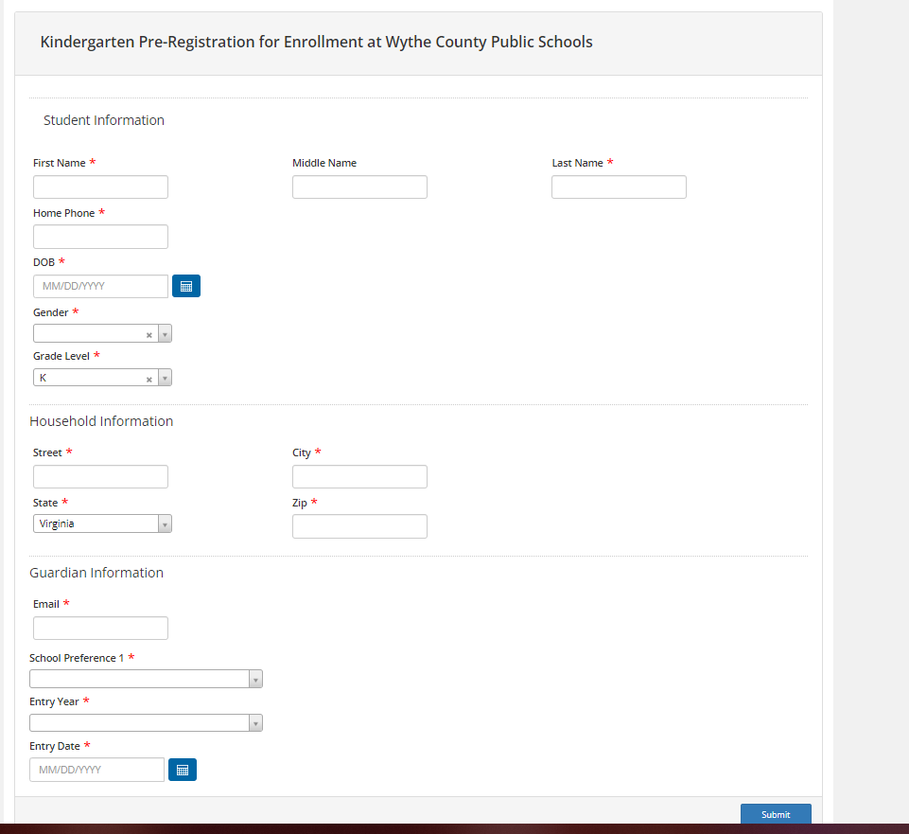

- The Pre-Registration form is just the first step of the enrollment process. This does not mean your child automatically is approved to attend the school you are registering at.
- There is only ONE Pre-Registration form. This Pre-Registration form can be used to register students for Kindergarten for the next school year.
- Once the school registrar approves the Pre-Registration the parent submits, the parent will receive an email with directions to complete the Enrollment forms

Upon submission of the Pre-Registration form, parents will receive an email message that says:
Dear Parent/Guardian,
The Pre-registration you submitted to Wythe County Public Schools for ___ has been received. Your child’s Pre-registration will be reviewed by school staff. You will receive more information when it is processed.

After review, you will receive an email letting you know the next steps for completion of your child's registration.

Check your email for additional instructions concerning your child’s pre-registration.

Email #1 New Student Enrollment Pre-Registration Received!
Thank you for beginning the pre-registration process for enrolling a new student with Wythe County Public Schools.

Email #2 Pre-registration Approved Email:
Once the school approves your pre-registration form, you will receive an email containing directions to create your Parent Portal. You must log in to your Parent Portal to access the required enrollment forms.
If you have any questions, please call the school your student will be attending.

Step 1: Set up a PowerSchool Parent Portal Account
If you do not already have a Parent Portal account, you can set one up by doing the following:
- Open the internet browser on your computer
- Type (or copy and paste) https://wythe.powerschool.com/public/ into the address bar.
- Click on "Create Account" Tab
- Fill in the information requested for your desired username and password.
- Enter your student's full name, Access ID and Password (provided in the email)
PowerSchool Address: https://wythe.powerschool.com/public/

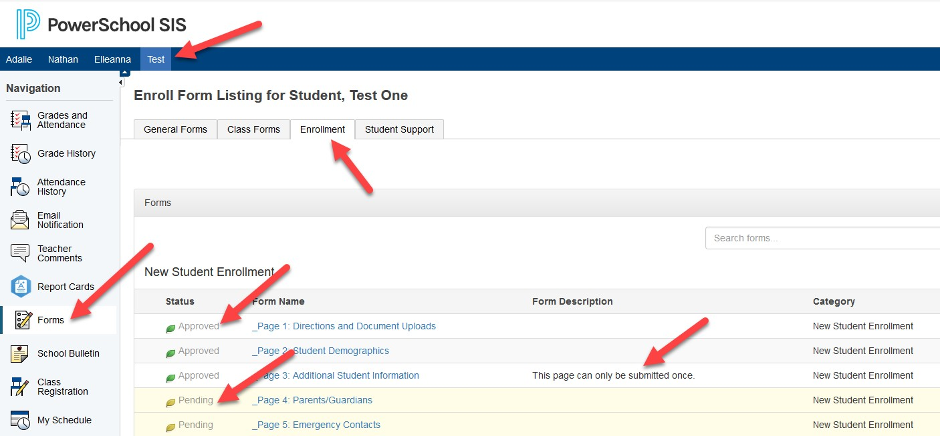
If a parent already has a Parent Portal account, they simply need to log in and use the information/directions above to add their new student to their existing Parent Portal account. If the parent does not have a parent portal account, they will need to follow the directions above to create a new account and add their new student to their parent portal so they can access the Enrollment forms. Once the new student has been added to the Parent Portal, the parent can click on Forms in the Navigation area on the left, then click on the Enrollment tab near the top, and then click on the link. At the bottom of each Enrollment Page, there is a Save for Later button and a Submit button. When the Parent clicks on Submit, the next Enrollment Page will appear, moving them through the Enrollment forms in order. As the parent submits each page, the page will turn light yellow and have a Pending Status. As the school registrar approves each page of enrollment, the page status will turn back to white and show it has been Approved. Certain pages are only allowed to be submitted by the parent ONCE. This is noted in the Form Description of the Enrollment Page. Unless noted, the Enrollment Page can be submitted more than once and it will return to Pending Status while awaiting approval from the school registrar.

Step 2: Complete Enrollment forms **All Forms must be complete before student is enrolled in Wythe County Schools.
In the Parent Portal, select the student you are enrolling at the top and click on the Forms link in the left Navigation menu.
**Please submit all enrollment forms promptly. Your child is not registered until all forms are complete.

Step 3: Provide Documentation
If you are unable to upload documentation via the document upload elements on the Enrollment forms, please bring the following documentation to your student's school office promptly so your child will be fully registered.
**School offices are open Monday-Friday between 8:00 AM-4:00 PM.

- Two Proofs of Address
- Child's birth certificate
- Copies of parent' IDs
- Proof of immunizations

If there are any issues with the Pre-Registration form or the Enrollment forms, the school registrar will reach out to the parent through email or a phone call to get further information.

